Project Design Phase-II
Data Flow Diagram & User Stories
Date | 13 July 2026
Team ID
Project Name | Voice-Based Concept Understanding Analyzer (VBCUA)
Maximum Marks | 4 Marks
Data Flow Diagrams:
A Data Flow Diagram (DFD) is a traditional visual representation of the information flows within a system. A neat and clear DFD depicts the right amount of system requirement graphically. It shows how data enters and leaves the system, what changes the information, and where data is stored.
The diagrams below describe the data flow of the Voice-Based Concept Understanding Analyzer (VBCUA): Figure 1 presents the Level 0 (context) view of the system as a single process exchanging data with its user, and Figure 2 decomposes that process into the Level 1 pipeline of transcription, semantic comparison, scoring, and report generation implemented in the application.
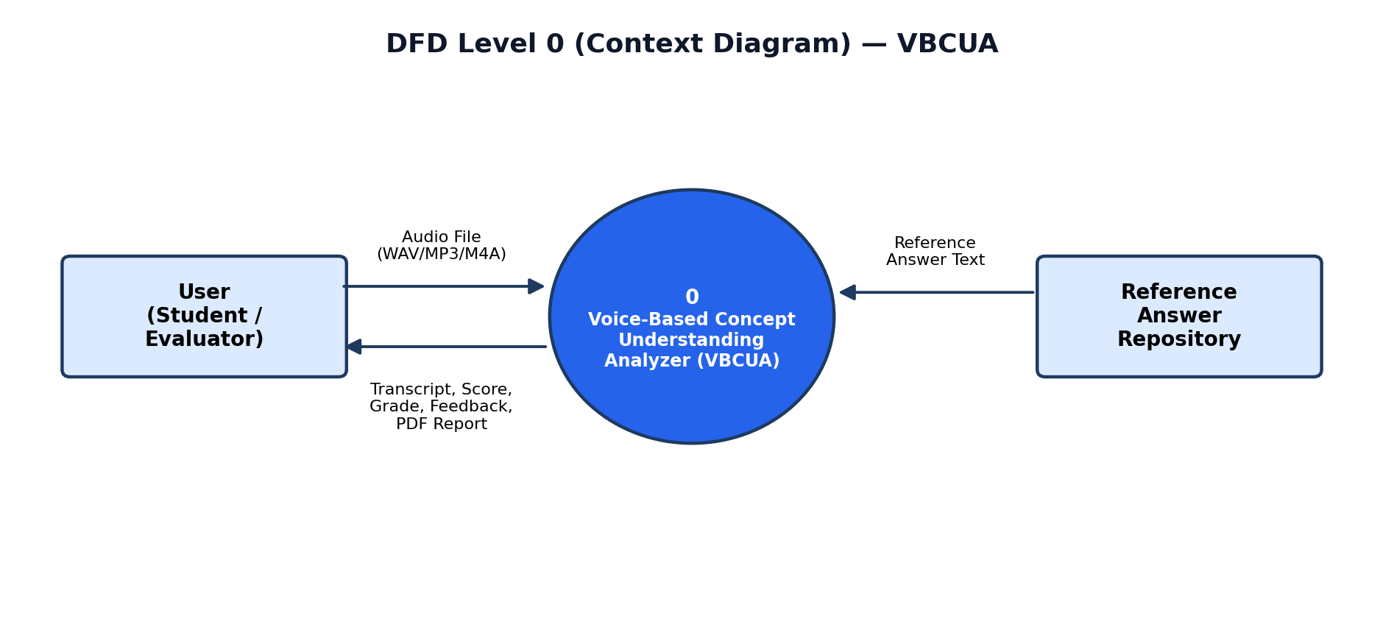
Figure 1: DFD Level 0 (Context Diagram) — VBCUA
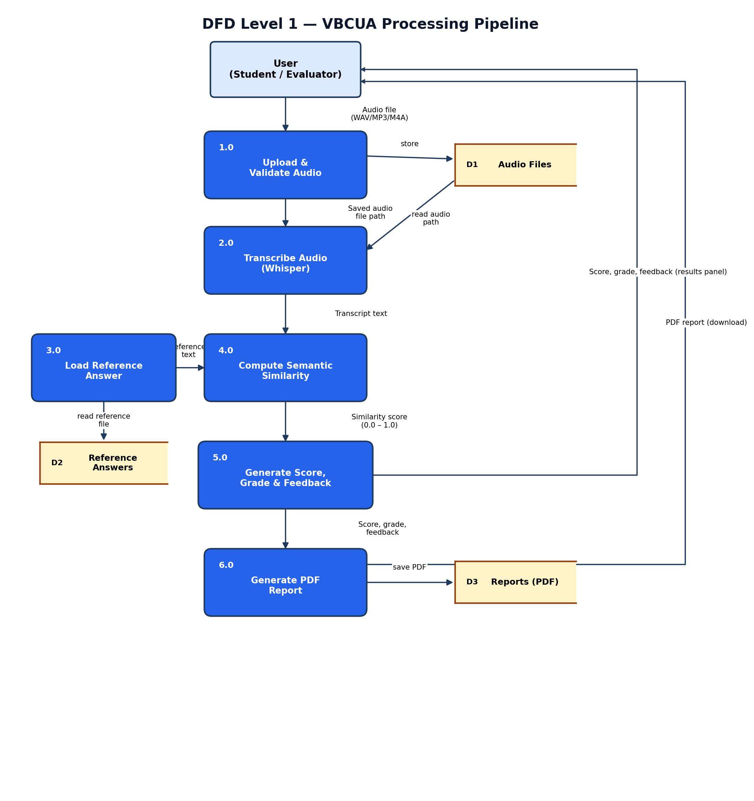
Figure 2: DFD Level 1 — VBCUA Processing Pipeline
User Stories
Use the below template to list all the user stories for the product.
User Type | Functional Requirement  (Epic) | User Story  Number | User Story / Task | Acceptance Criteria | Priority | Release
Student  (End User) | Audio Upload | USN-1 | As a student, I can upload a recorded audio file of my spoken explanation so that it can be evaluated. | Selecting a WAV, MP3, or M4A file uploads successfully and a confirmation message with the file name is shown. | High | Sprint-1
 |  | USN-2 | As a student, I want unsupported audio file types to be rejected so that I only upload a file the system can process. | Selecting a file outside the WAV/MP3/M4A formats is blocked by the uploader before submission. | Medium | Sprint-1
 | Speech-to-Text  Transcription | USN-3 | As a student, I want my audio automatically transcribed into text so that I can see what the system understood from my explanation. | After upload, a text transcript of the spoken response is displayed on screen. | High | Sprint-1
 |  | USN-4 | As a student, I want to be notified if transcription fails so that I know to re-upload my audio. | A descriptive error message is shown when transcription cannot be completed. | Medium | Sprint-2
 | Semantic Similarity  Analysis | USN-5 | As a student, I want my transcript compared against a reference answer so that my understanding can be measured objectively. | A similarity score between 0% and 100% is generated once transcription completes. | High | Sprint-1
 | Concept Understanding  Scoring | USN-6 | As a student, I want to receive a grade (Excellent / Good / Fair / Needs Improvement) so that I can quickly gauge my performance. | A grade label is displayed together with the percentage score. | High | Sprint-1
 |  | USN-7 | As a student, I want written feedback explaining my grade so that I understand what to improve. | A feedback message specific to the grade tier is shown below the score. | Medium | Sprint-1
 | Results Display | USN-8 | As a student, I want to view my transcript, score, and feedback together on one screen so that I can review my performance at a glance. | The results panel displays transcript, similarity metric, grade badge, and feedback simultaneously. | Medium | Sprint-1
 | PDF Report  Generation | USN-9 | As a student, I want a PDF report of my assessment generated automatically so that I can keep a record of my performance. | After analysis completes, a PDF containing the transcript, score, grade, and feedback is created. | Medium | Sprint-2
 | Report Download | USN-10 | As a student, I want to download my PDF report so that I can save or share it. | A working download button appears once a report has been generated for the current session. | Medium | Sprint-2
Evaluator /  Instructor | Reference Answer  Management | USN-11 | As an evaluator, I want the system to use a stored reference answer for comparison so that grading is based on a consistent standard. | The system loads and validates the reference answer file before scoring begins. | High | Sprint-1
 | Results Display | USN-12 | As an evaluator, I want each submission to show a clear grade tier so that I can quickly identify students who need support. | Each result includes a colour-coded grade badge corresponding to its assessment tier. | Medium | Sprint-2

